
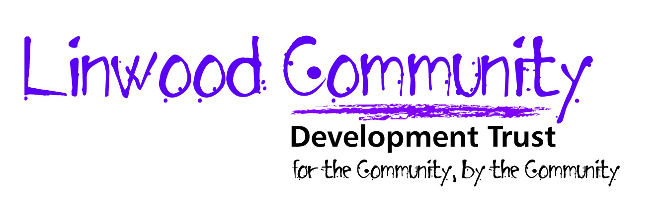

To complete the form:
Save the form under another name. Point your mouse arrow on to the highlighted portions or use the tab keys to move between the highlighted fields. You must complete the application form in full.

Part A

Post Details
Post applied for:

Personal Details
Surname |  |  |  |  | Forenames
Title |  |  |  |  |  | Phone numbers (please specify your preferred number)
Home Address |  |  |  |  |  | Home  Mobile  Alternative
Post code |  |  | National Insurance Number |  |  |  | Tick If you do not wish to provide an email address and wish to receive correspondence via post
E-mail address. This will be used for all future correspondence

Entitlement to Work in UK
Linwood CDT values diversity and welcomes applicants from all backgrounds. If you are successful in obtaining employment with us you will be required to provide evidence of your entitlement to work in the UK. If you are not a British or Commonwealth Citizen with the right of abode in the UK, or a citizen of any country in the European Economic Area (EEA), you will require a work permit.

(place a ‘X’ appropriate box) | Yes | No
Are you a British Citizen or Commonwealth Citizen with the right of abode in the UK, or a citizen of any country in the EEA?
If no, do you require a work permit to work in the UK?
If you have answered yes to question 2 above, do you have a work permit to work in the UK?

Part B: Education
Please provide details of your qualifications, this may include formal vocational training and should be in chronological order starting with your most recent. Evidence may be required. (Continue on a separate sheet if necessary)
Qualifications obtained or currently studying towards | Dates From | To | Institution | Main Subjects Studied

Membership of Professional Bodies (if applicable)
Professional Body | Current Status (e.g. Fellow: Full member; Graduate; Student; Licentiate; Associate, etc.) | Date obtained

Current/Most Recent Employer
Employer |  | Post Held: | Dates From | To
Address  Tel No |  | Summary of duties:
Please give reason for leaving/wishing to leave current or most recent employer:

Notice Period required by current employer (if applicable):
Current or most recent salary:
Employment History
Please provide details of your employment history, in date order starting with the most recent.
Employer |  | Post Held: | Dates From | To
Address  Tel No |  | Summary of duties:
Employer |  | Post Held: | Dates From | To
Address  Tel No |  | Summary of duties:
Employer |  | Post Held: | Dates From | To
Address  Tel No |  | Summary of duties:

Referees
Please provide the names and telephone numbers of two employer referees, which should include your current or most recent employer, if applicable. Referees will only be contacted for applicants invited to interview.
Name | 1) | 2)
Employer
Address
Telephone
Email
Can we contact this referee prior to interview if shortlisted

Job Advert
Where did you see this post advertised?
Availability for interview i.e. morning, afternoon or evening?

Disability
Linwood CDT welcomes applicants who self-assess themselves as having a disability. Disability is defined as a physical or mental impairment that has a substantial or long-term adverse effect on a person’s ability to carry out normal day-to-day activities.
(please tick appropriate box) | Yes | No
Do you consider yourself to have a disability?
This information is needed so that all applicants who have a disability and who meet the minimum essential criteria for the post are offered an interview.
If yes, what if any types of aids, adaptations, equipment or special arrangements would you require to attend an interview?

If you were to be a successful candidate, would you require any additional support from us as your employer to enable you to carry out the functions of the post?

Statement in Support of Application:
Please use this section to demonstrate how you believe your skills and experience match those detailed in the advert and post information. Please explain your reasons for the interest in the post and give details of special skills/attributes that you feel are relevant to your application, including interests, voluntary work, involvement in community activities.

The information in this application is a true record of my personal situation

Signature: Date:

Please return your completed form to the address below, either by post or by e-mail.

Please also return your equal opportunities monitoring form with your application; all applications are opened by a member of staff not involved in the interview process. The monitoring form is detached from your form, is stored separately and is not seen by the interview panel. We use the monitoring forms to compile data on the general trends in our applications only.

Part C: Declarations
Membership Of Protection of Vulnerable Groups (PVG) Scheme
All applicants selected for interview will be required to complete and submit, prior to interview, a Self Declaration Form

Successful candidates will then be required to undertake an appropriate level of disclosure record. In the event of employment any failure to disclose information could result in dismissal or other disciplinary action by the Board. Any information will be treated in the strictest confidence.

I certify that the information provided on this form and in any attachments is correct and understand that any misrepresentation or omission may lead to dismissal without notice. I understand that the information I have given may be stored in manual and electronic files and is subject to the provisions of the Data Protection Act 1998. I agree to information provided on this form being used by Linwood CDT in accordance with the Act and that if I am unsuccessful all documentation related to my application will be confidentially destroyed after 6 months.

Signature: | Date:

If submitting by email, you will be required to physically sign this section at interview.

Please return to: kirsty@linwoodtrust.org.uk or post the application to the address opposite if you have elected to receive communications via post. | Linwood Community Development Trust  Unit 19, Mossedge Industrial Estate  Moss Road  Linwood  Renfrewshire PA3 3HR
Thank you for your interest in working with us.

Linwood Community Development Trust is a registered Scottish charity (Charity No: SC043633)
Registered in Scotland as a company limited by guarantee (Company No: SC428650)
Registered office: Unit 19, Mossedge Industrial Estate, Moss Road, Linwood, Paisley, Renfrewshire PA3 3HR

EQUALITY AND DIVERSITY
MONITORING FORM

We are striving to provide equal opportunities for all. It is our aim to ensure that we are representing all sections of the community.

Your cooperation in completing this form would be greatly appreciated. We must stress that any information you give will be treated in the strictest confidence. You are not obliged to answer any of the questions, but to help us achieve our aims we would appreciate this information.

The information you provide will be treated in the strictest confidence and will be used for monitoring purposes only. This information will not be circulated to the interview panel.

1) Ethnic Origin – how would you describe your ethnic origin?
White |  |  |  |  |  | Asian |  |  |  |  |  |  |  | Black |  |  |  |  |  | Other ethnic origin
Scottish |  |  |  |  |  | Indian |  |  |  |  |  |  |  | Caribbean |  |  |  |  |  | Mixed Ethnic Origin
Other British |  |  |  |  |  | Pakistani |  |  |  |  |  |  |  | African |  |  |  |  |  | Other
Irish |  |  |  |  |  | Bangladeshi |  |  |  |  |  |  |  | Scottish Other
Other European |  |  |  |  |  | Chinese |  |  |  |  |  |  |  | British Other
Other |  |  |  |  |  | Other |  |  |  |  |  |  |  | Other
2) Gender
Male |  |  |  |  |  | Female
3) Age
Under 25 |  |  |  | 25-40 |  |  |  |  |  | 41-50 |  |  |  |  |  |  | 51-65 |  |  |  |  | 65+
4) Disability
I consider myself to be a disabled person |  |  |  |  |  |  |  |  |  |  |  |  | I am a non disabled person
We appreciate that some people may find the question on sexual orientation an extremely personal one and we must therefore re-iterate that you are under no obligation to answer it. To promote inclusive practice, we are keen to ensure
that the views of all our sections of the community are represented in our activities.

I would describe myself as:
Heterosexual |  |  |  |  | Lesbian |  |  |  |  |  | Gay |  |  |  |  | Bisexual |  |  |  |  | Other

